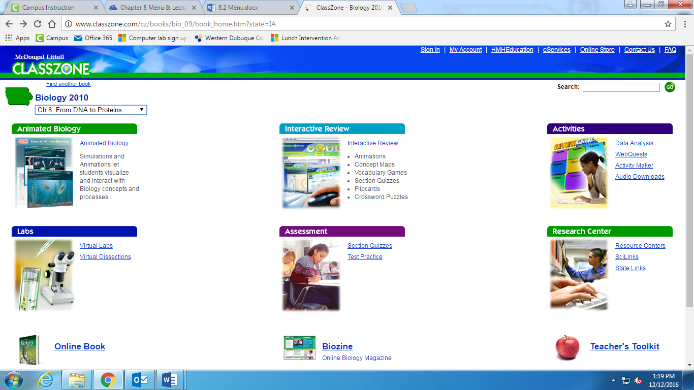

Go to [www.classzone.com](http://www.classzone.com)

Enter science, high school, Iowa and select 2010 book.

The screen to left should appear. Click on Activities: Data Analysis or Webquest

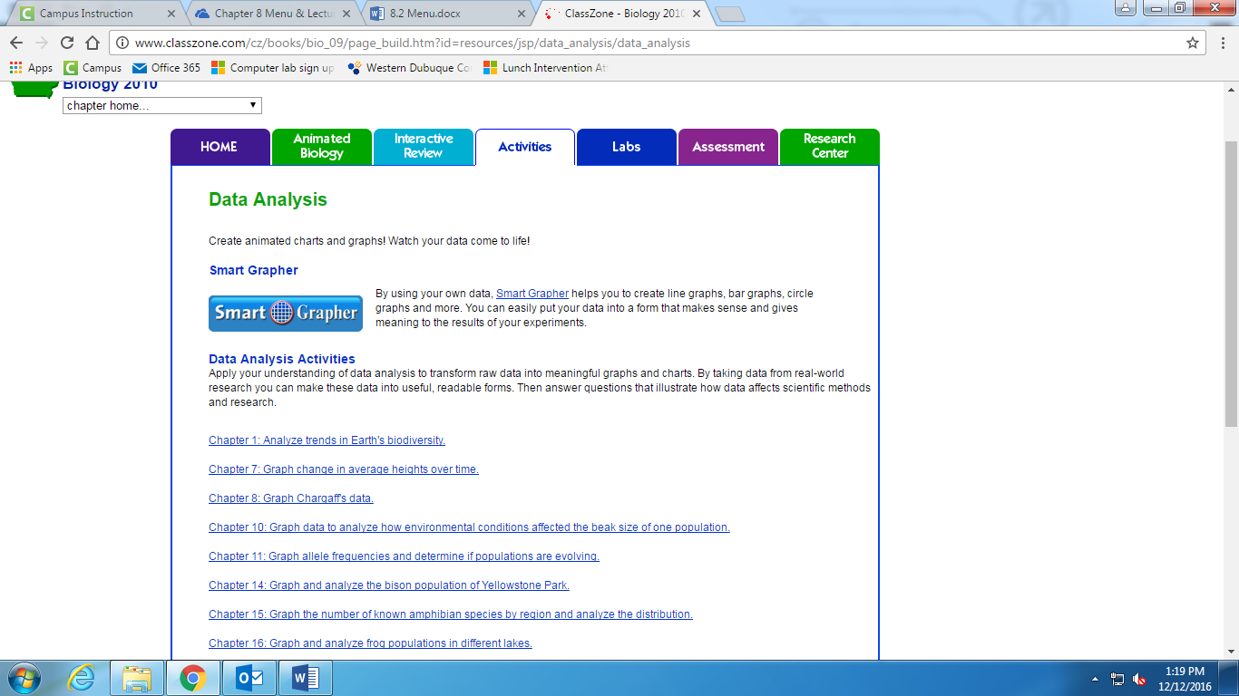

If you want to do data analysis: click on Chapter 8: Chargaff’s Rules and do the on screen activity.

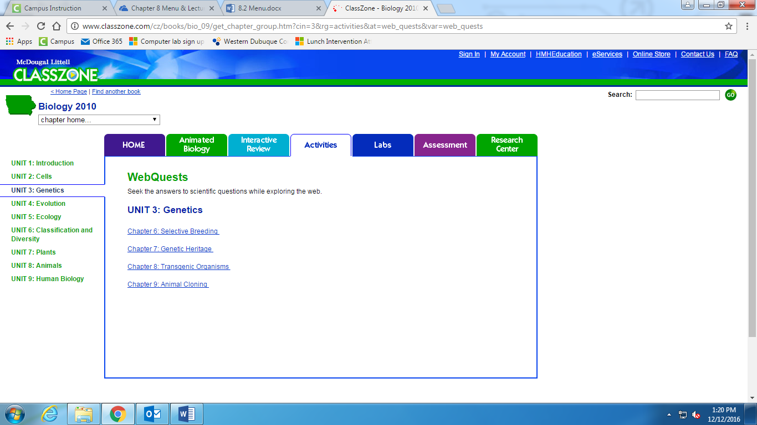

If you want to do webquest: click on Unit 3: Genetics and then Chapter 8: Transgenic Organism. Follow the on screen activity.